Lab Exercise 9– Creating Replicaset in Kubernetes
Below is a lab exercise that will help you understand and practice creating a Replicaset in Kubernetes:
Step 1: Create a ReplicaSet Configuration File
Create a file named replicaset.yaml with the following configuration:
Link of file: (Copy following code from my GitHub repo)
https://github.com/hkshitesh/ACO-LAB-2021-25/blob/main/scripts/replicaset.yaml
apiVersion: apps/v1
kind: ReplicaSet
metadata:
name: my-nginx-rs
spec:
replicas: 3
selector:
matchLabels:
app: lbnginx
template:
metadata:
labels:
app: lbnginx
spec:
containers:
- name: nginx
image: nginx

Step 2: Apply the ReplicaSet Configuration
Apply the configuration to create the ReplicaSet:
kubectl apply -f replicaset.yaml
Output -
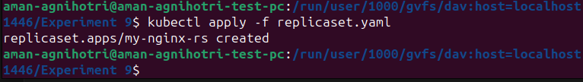
Step 3: View the ReplicaSet and Pods
View the created ReplicaSet and the associated Pods:
kubectl get replicaset
kubectl get pods
Output -
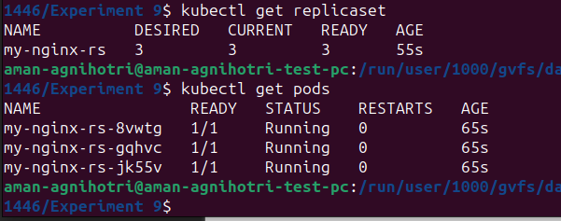
Step 4: Scale the ReplicaSet
Scale the ReplicaSet to 5 replicas:
kubectl scale replicaset my-nginx-rs --replicas=5

Output -
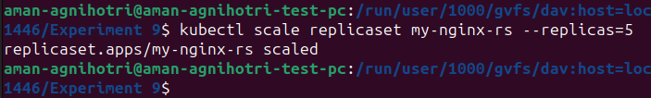
Step 5: Delete the ReplicaSet
Delete the ReplicaSet:
kubectl delete replicaset my-nginx-rs
Output -
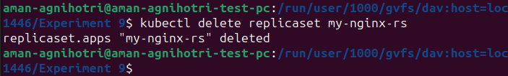
Conclusion
This exercise demonstrated how to create, manage, and update a ReplicaSet in Kubernetes. You learned how to scale the ReplicaSet, update the image, and delete the ReplicaSet from the cluster. Experiment further with different configurations and scaling options to deepen your understanding of managing ReplicaSets in Kubernetes.

